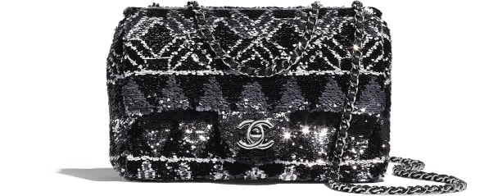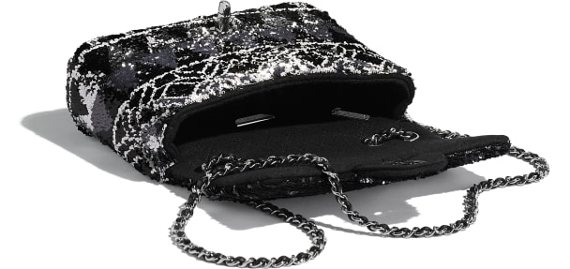

**Flap Bag**

Sequins & Ruthenium-Finish Metal

Silver & Black

15 × 22 × 7 cmin

Reference: AS1078 B01638 N4552

**CAN$6,450**